**SUMMERFEST T-SHIRT ORDER FORM**



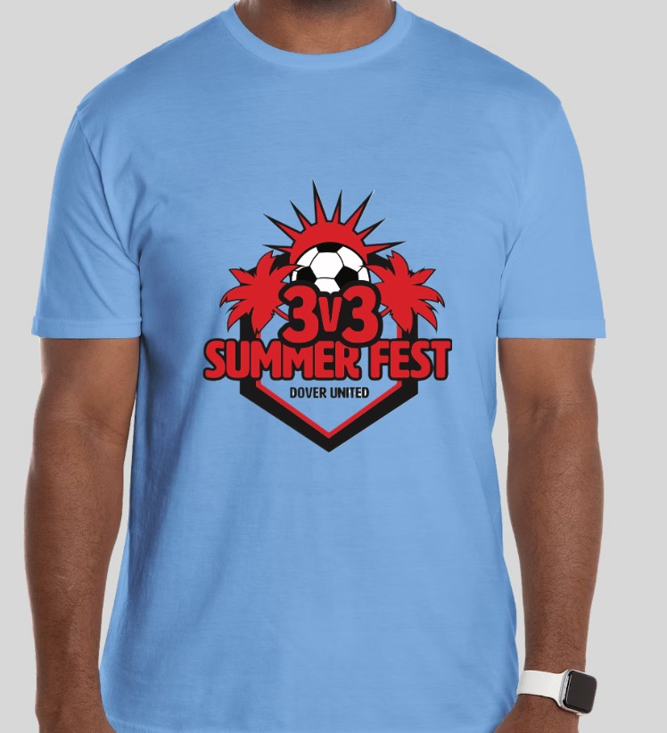 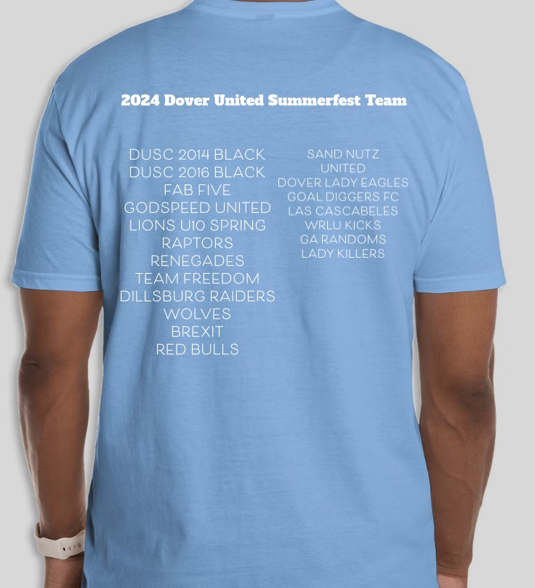

(***Order for the entire Team on this form***)

**T-shirt size Qty. ordered Cost per shirt Total cost**

|  |  |  |  |  |
| --- | --- | --- | --- | --- |
| Youth Medium |  | x $20.00 | = |  |
| Youth Large |  | x $20.00 | = |  |
| Adult Small |  | x $20.00 | = |  |
| Adult Medium |  | x $20.00 | = |  |
| Adult Large |  | x $20.00 | = |  |
| Adult X-Large |  | x $20.00 | = |  |
| Adult XX-Large |  | x $23.00 | = |  |
| **Total Qty. ordered:** |  | **Total cost:** | = |  |

Team Name:

Age Group: *(circle one)* **U9/10 U11/12 U13/14 High School** Gender: *(circle one)* **Male / Female**

Contact Person: Cell Phone:

*(Please DO NOT write below DUSC officials only)*

Check # Date Received: Order Ref #

Please send this form and send only **one** check payable to: ***DUSC***

Send to:

# *Summerfest T-shirts c/o Mel James* 1884 Ashcombe Dr

***Dover, PA 17315***