The Fall Season we will have the following teams:

* 1 Male 2014 team – Coach Benshoof
* 1 Male 2015 team – Coach Fischer
* 1 Male 2016 team – Coach Houdeshell
* 1 Female 2015 team – Coach Genoe

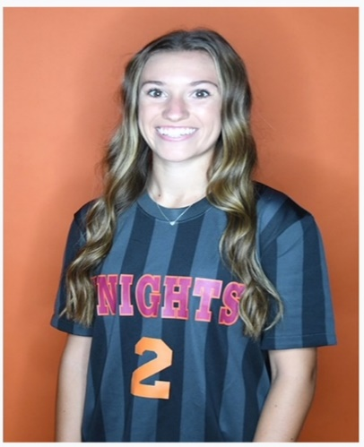Academy Coordinator Spotlight **– Kacie Hoppel**

Kacie is a Dover graduate that has played soccer at both the high school and

collegiate level. Kaci was recognized as First Team All-Conference in 2023

and is completing her last semester of clinicals as a PTA Major. We look

forward to having Kacie give back to Dover United and the Dover Community.

**WELCOME KACIE!**

**OPENINGS/HELP NEEDED:**

* *The U9 girls’ team is looking for a few girls to add to Coach Roberts team. If you know anyone, please reach out to Coach Robert @****robertg787@ymail.com***
* *The Board welcomes all parents to volunteer we are always looking for any new members, as we continue to grow. Board Meetings are Held @ the Community Center the 2nd Thursday of every month from 7:00-8:00pm unless otherwise noted.*

**UPCOMING EVENTS WITH DOVER UNITED … PLEASE MARK YOUR CALENDARS**

**October 12th & 13th** – *Dover United will be hosting the Dillsburg Shoot out @ Lehr Park, all proceeds will benefit the Dover HS Boys Soccer Team. Stop by and support Dover Boys Soccer. Volunteers from the club are always welcome. We need help in the Concessions, Field Marshalls as well as score runners. We also need help with lining and setting up the fields prior to the tournament.*

*The Boys U10 team will be playing at our Lehr site- come show your support.*

*October 23rd- Trunk or Treat @ North Salem Elementary*

***\*\*\*\*\*\*\*\*\*\*R&K SUBSs***

Our Fundraising Coordinator Emily has officially set up another R&K Subs Fundraiser for Dover United:

Sub/Sandwich kick off will be the week of 9/9

Pickup will be 10/8 between 5:00 – 7:00 pm @ Lehr Park

**PICTURES: SETEMBER 12th**

Focus on the good things

This year we will be working with Orendorff Studios to get Soccer Pictures. Their studio does amazing photos – check out their website @ [www.orendorffstudios.com](http://www.orendorffstudios.com)

Pictures will be done inside at the Heritage Center for weather purposes. Schedule will be as follows:

*6:00 PM - Benshoof

*6:15 PM - Houdeshell

*6:30 PM- Fischer

*6:45 PM- Genoe

*7:00 PM -Academy

**Make Up dates will only be at the Orendorff Studio 402 Wheatfield Street York, PA**

* **Friday- September 6th and 13th 4:00-7:00 pm ONLY**